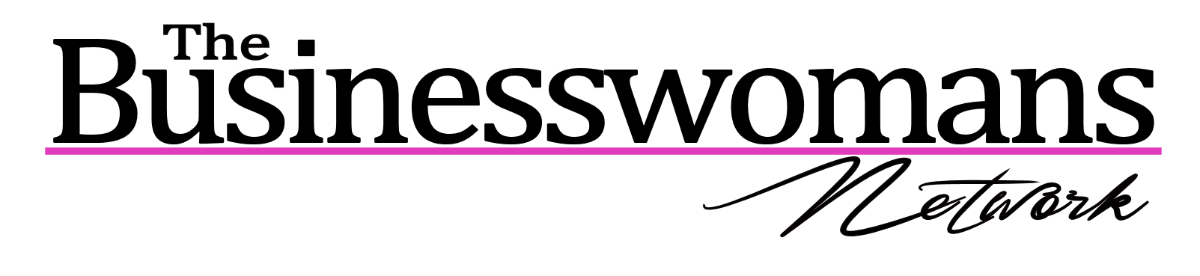Speaker policy
Thank you; Thank you for agreeing to speak at our event. We aim to bring true experts to our events to increase the sales, confidence and success of women in business, thus we appreciate your support and will do all we can to promote you and your work.
Promoting you; We will promote you in our online marketing on social media, in our newsletters and on our website as well as at events prior to your master class with us and in our PR.
Photos; We will also be taking photos at our events. These photos are available for purchase from our corporate photographer. We will tag you in the images on Facebook so that we can further promote you after the event and should you wish to purchase any images you can contact our corporate photographer on the cover of the Facebook album to arrange this. (They are sold to our speakers at a greatly reduced price.) Please do not use these in your own digital marketing without our permission, this contravenes are corporate photographers IP and our photographer’s policy. (We do not make any money from the sale of these images.)
Video; With your permission we will take short videos that we will post on our YouTube channel and on our social media and utilise in our digital marketing after the event to promote you. Should you wish for us not to do this please advise your coordinator.
Facebook Live; With Facebook Live some speakers like the audience to film clips to showcase them, however you may prefer for your content not to be released in this way so please advise your coordinator so that we are able to best support you when you speak at our event.
Providing content for use please; By providing us with any links to show reels, social media links, web links, books, upcoming training days or events you are hosting your local coordinator will be able to include these in the promotion of your speaking engagement with us.
Use of our brand, images and IP; Please do not place images including the BWN logo on to your own website or other promotion material without our prior consent. This is something we are happy to explore as we like to promote you long after you have spoken for us, however we like to know where our brand is being utilised and in what capacity and would prefer for our weblink to be included if it is used.
If there are other ways you feel we can support you and work with you in the future, please do not hesitate to advise us.

