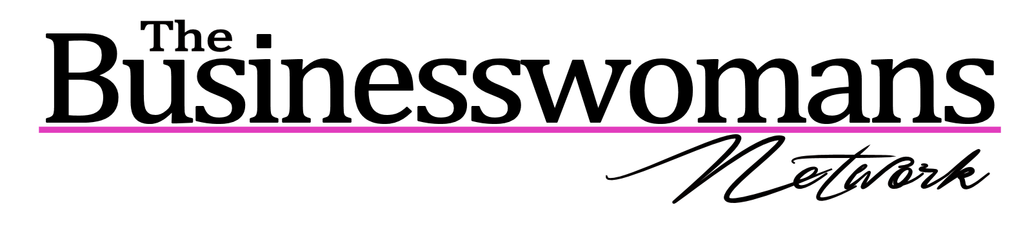The BWN Photography Policy
Please be mindful that you do not have permission to use our images without our prior consent in your own marketing material. Of course you can tag your business in our images in our digital marketing, chat on our images, talk about which events you will be attending, etc., etc... (All good for your online marketing!)
If you love an image just let us know via your local coordinator and you can purchase it for a greatly reduced price from our corporate photographer. That is their Intellectual Property and we get their permission to use it in our marketing. Thank you.
For Essex events to use images please contact Jayne Lloyd or visit http://www.jaynelloyd.co.uk/bwn160915 Jayne’s images start from as little as £20.
Please note we take photos at every BWN event to further support your promotion and enable us to help you and your business become well known between events. By tagging you in these photos it enables us to ensure people remember you and your business. If you would not like to feature in any photos, please advise the coordinator at the time of the event or get in touch.
We completely respect you and your business and are here for your success. Thank you for your understanding in this matter.
Please also note that the master class section of ALL events is NOT to be recorded in any format.
---------------------------------------------------------------------------------------------------------
Coordinators please note you should print this document and put this on the promo table or on the refreshments stand. Alter the photographer’s details accordingly and you are welcome to add their logo below The BWN logo too. On printing remove this italic statement. Thank you.

