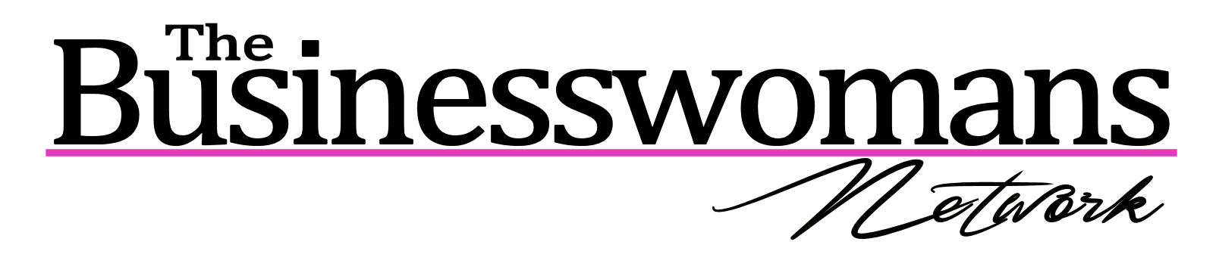
The Business Womans Network Refund Policy
Please note that because The BWN does not have a traditional membership we work closely with our venues to keep costs and administration to a minimum, as such we have to abide by the refund policy. Although we will do all we can to accommodate busy business women;

More than one week to the date of the event; Full refund on your purchased ticket.
Less than one week to the date of the event; No refund on your purchased ticket however, choose a different date to attend at that venue.
On the day of the event; No refund and no alternative date.

We apologise for any inconvenience that this may cause; however, we incur costs for tickets purchased. Should you feel that you fit exceptional circumstances and with to discuss this we are happy to do this and are always open to new ideas to enable us to help women in business more.
The BWN – As Passionate About Your Success As You.

